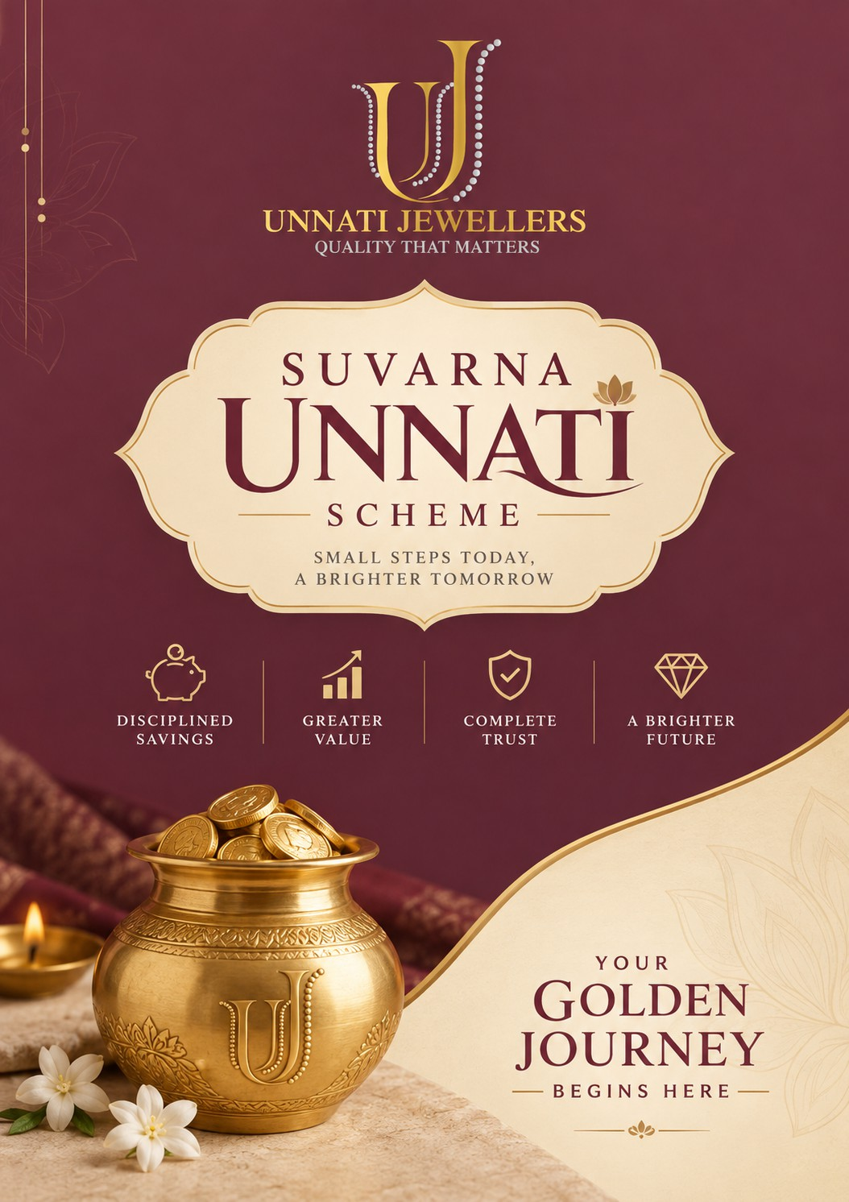




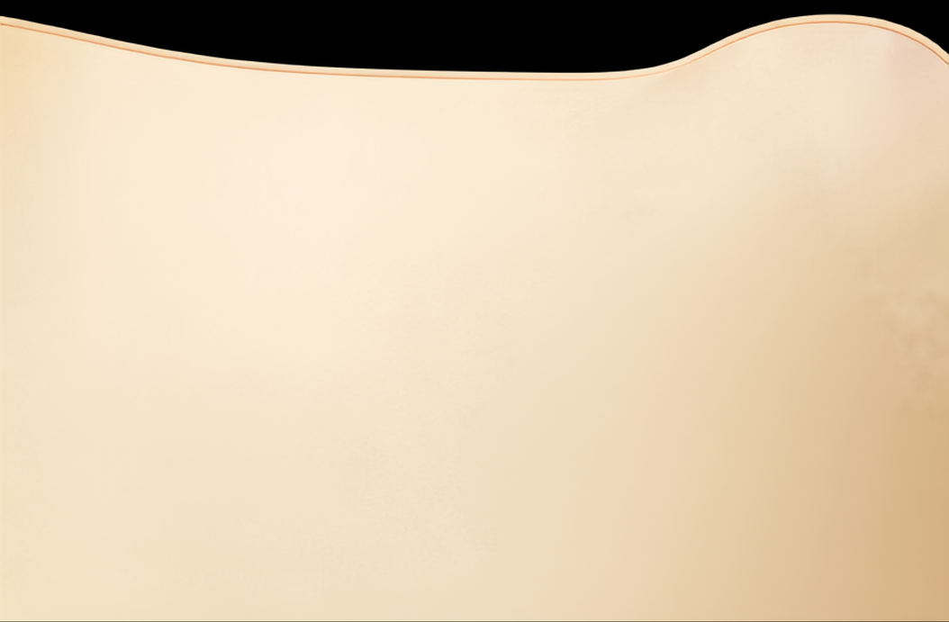














T W O T H O U G H T F U L W A Y S T O
Save in Gold
CHOOSE THE SCHEME THAT SUITS YOUR GOAL

S U V A R N A U N N A T I

Weight Based Scheme
A C C U M U L A T E G O L D , F O R A B R I G H T E R T O M O R R O W
Every monthly installment is converted into gold at the applicable gold rate on the payment date. Your accumulated gold is redeemed against jewellery at maturity.

Accumulates gold
at today’s rate every month

Benefit from gold appreciation
over time

Redeem against jewellery
at scheme maturity

Cancel: refund minus 20%
of one month’s installment

BIS Hallmarked
22K / 18K Gold available

S U V A R N A U N N A T I

Amount Based Scheme
Your
commitment
F I X E D S A V I N G S , T I M E L E S S V A L U E .
today, a
Your monthly installments remain as money throughout the tenure. At maturity, the full accumulated amount is redeemed against jewellery at Unnati Jewellers.
more
valuable
tomorrow

Fixed Savings
Installments retained as currency

Predictable
no market dependency

Full amount redeemable
against jewellery at maturity
Cancel: 100% refund
of all deposited installments

Secure • Transparent • Hassle-free
Ledger maintained with digital receipts

T R U S T E D T O D A Y, V A L U A B L E A LW A Y S .

